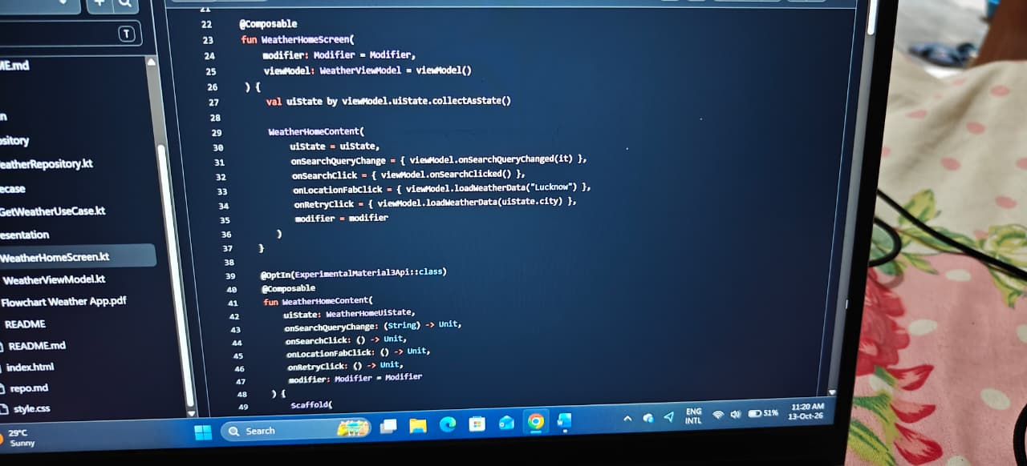

WEATHER HOME SCREEN

